Packet Tracer – Troubleshoot VTP and DTP

1. Topology

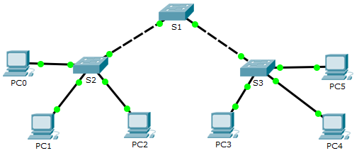

1. Addressing Table

|  |  |  |
| --- | --- | --- |
| Device | IP Address | Subnet Mask |
| PC0 | 172.16.10.1 | 255.255.255.0 |
| PC1 | 172.16.20.1 | 255.255.255.0 |
| PC2 | 172.16.30.1 | 255.255.255.0 |
| PC3 | 172.16.30.2 | 255.255.255.0 |
| PC4 | 172.16.20.2 | 255.255.255.0 |
| PC5 | 172.16.10.2 | 255.255.255.0 |
| S1 | 172.16.99.1 | 255.255.255.0 |
| S2 | 172.16.99.2 | 255.255.255.0 |
| S3 | 172.16.99.3 | 255.255.255.0 |

1. Objectives

Part 1: Troubleshoot DTP

Part 2: Troubleshoot VTP

1. Background / Scenario

In this activity, the switches S2 and S3 are not implementing VTP information. You will verify that DTP and VTP configurations are correctly implemented. When all the issues are resolved, the PCs in the same VLAN will be able to communicate with each other.

1. Troubleshoot DTP

In Part 1, you will troubleshoot the trunk links among the switches. You will verify that permanent trunk links are used between the switches.

* + - 1. Enter **show interfaces trunk** at the privileged EXEC prompt on all the switches to determine the status of the trunk links. How many trunk links are configured currently?

No hay enlaces trunk ya que al poner el comando en todos los switch no arroja ninguna información

* + - 1. Enter **show interfaces g0/1 switchport** at the privileged EXEC prompt on S1. Do the same for g0/2 interface on S1.

What is the operational mode on the GigabitEthernet interfaces on S1?

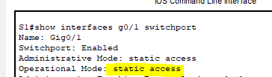

En ambas interfaces esta en modo de acceso estático

* + - 1. Repeat the commands for g0/1 on S2 and g0/2 on S3.

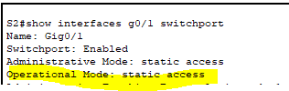

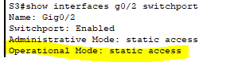

Correct the trunk links. Record the commands you used to correct the trunking issue.

Con los comandos para entrar en la interfaz en el caso del switch 1 lo hice por medio de la interfaz de rango

Enable

Config t

Interface range g0/1-2

Switchport mode trunk

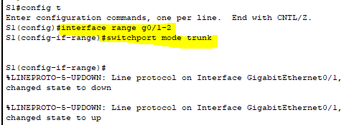

En el switch 2 y 3 solo una interfaz en el caso del S2

Enable

Config t

Interface g0/1

Switchport mode trunk

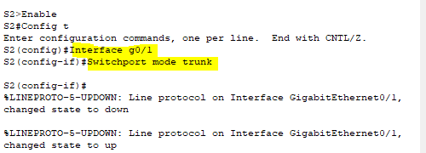

En el S3

Enable

Config t

Interface g0/2

Switchport mode trunk

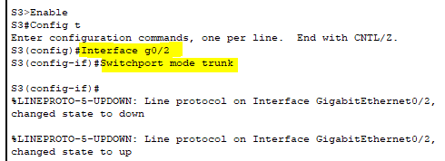

* + - 1. Verify the trunk links using the **show** commands.

1. Troubleshoot VTP
   * 1. Verify VLAN information

Use the **show vlan brief** command on all the switches. Do all the switches have the same number of VLANs? How many does each switch have?

S1 tiene 10 vlan no tiene las mismas todas ya que S2 y S3 cuentan con solo 7

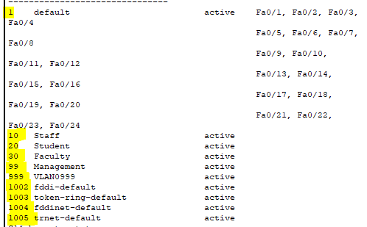

Tambien con el comando vtp status se puede saber el numero

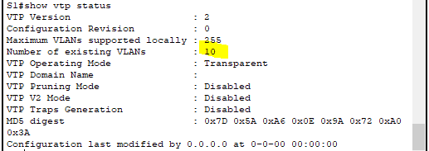

En S2 y S3 cuenta con 7

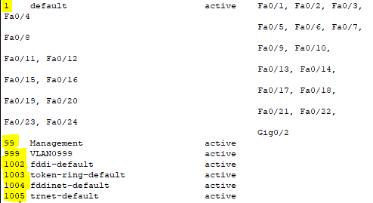

* + 1. Verify VTP configurations.

Use the **show vtp status** and **show vtp password** commands on all the switches to verify the VTP status.

Record the VTP status information in the table below.

|  |  |  |  |
| --- | --- | --- | --- |
| Device | Domain Name | Operating Mode | VTP Password |
| S1 | No tiene configurada | Transparent | No tiene contraseña |
| S2 | Ccna | Transparent | No tiene configurada |
| S3 | CCNA | Transparent | Contraseña Cisco |

* + 1. Correct the VTP configurations.

Ensure that switch S1 is operating as the VTP server. S2 and S3 should be VTP clients, and receiving VTP updates from S1. The VTP domain should be **CCNA**and the VTP password should be **cisco**. The desired VLANs are already configured on switch S1

Record the commands used to correct the VTP configurations.

Para el S1

vtp mode server

vtp domain CCNA

vtp password cisco

para el S2 y S3

vtp mode client

vtp domain CCNA

vtp password cisco

* + 1. Verify port assignment.

The switchports connecting to the PCs need to be configured in the correct VLANs so the PCs can communicate with each other.

Use the **show vlan brief** command on S2 and S3 to determine if VLANs have been assigned to the switchports. Which VLAN is associated with these switchports? La vlan 1

|  |  |  |
| --- | --- | --- |
| Ports | Assignments | Network |
| S2 F0/1  S3 F0/8 | VLAN 10 (Staff) | 172.16.10.0/24 |
| S2 F0/9  S3 F0/16 | VLAN 20 (Student) | 172.16.20.0 /24 |
| S2 F0/17  S3 F0/24 | VLAN 30 (Faculty) | 172.16.30.0 /24 |

Using the table above, correct the VLAN assignments on S2 and S3. Record the VLAN assignment configurations below.

S2:

interface f0/1

switchport access vlan 10

interface f0/9

switchport access vlan 20

interface f0/17

switchport access vlan 30

S3:

interface f0/8

switchport access vlan 10

interface f0/16

switchport access vlan 20

interface f0/24

switchport access vlan 30

* + 1. Verify end to end connectivity.
       1. From PC0 ping PC5.

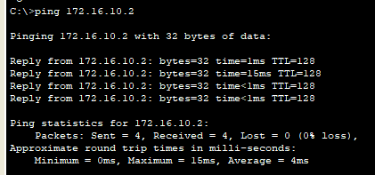

* + - 1. From PC1 ping PC4.

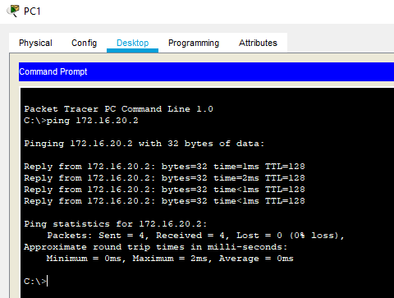

* + - 1. From PC2 ping PC3.

